**AWS – DEPLOY WORDPRESS WITH AMAZON** RDS

LAB -1 : Creating a MYSQL Database with RDS

* Log in AWS account
* Go to RDS

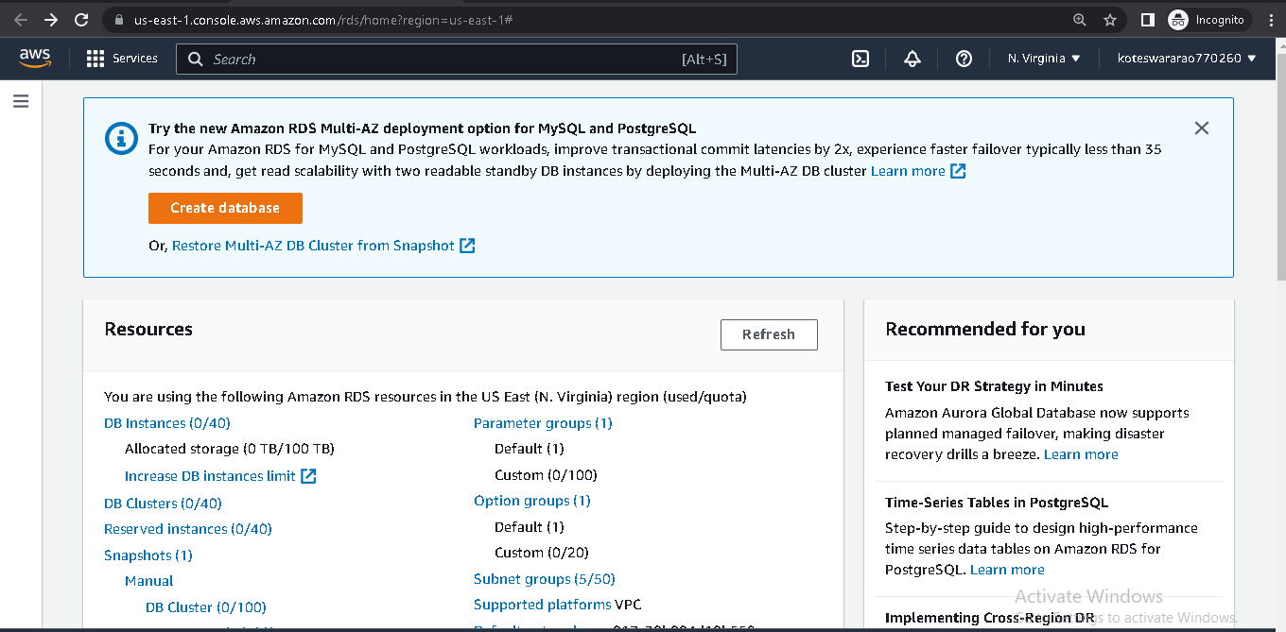

* Create Database
* Select standard create and MYSQL Engine

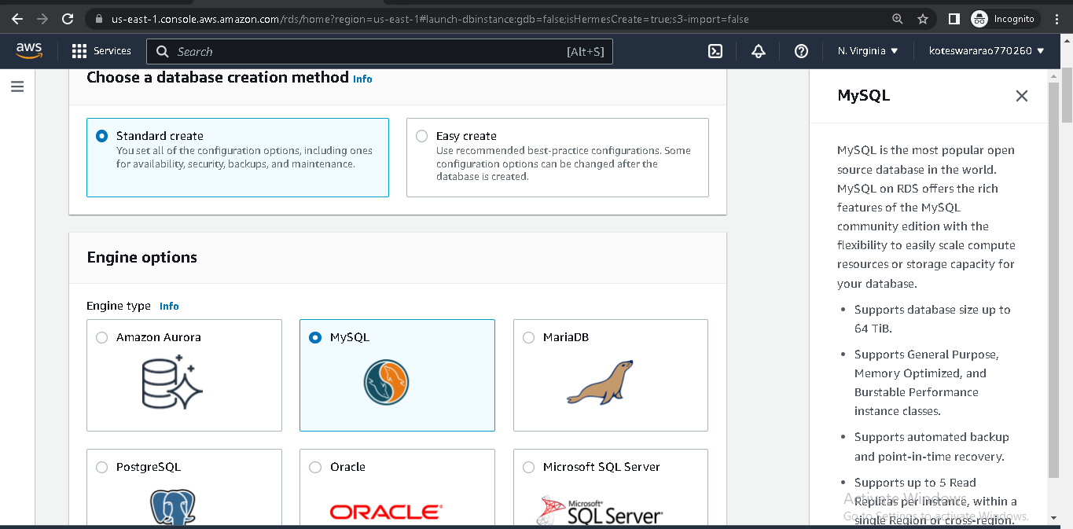

* Select template free tier

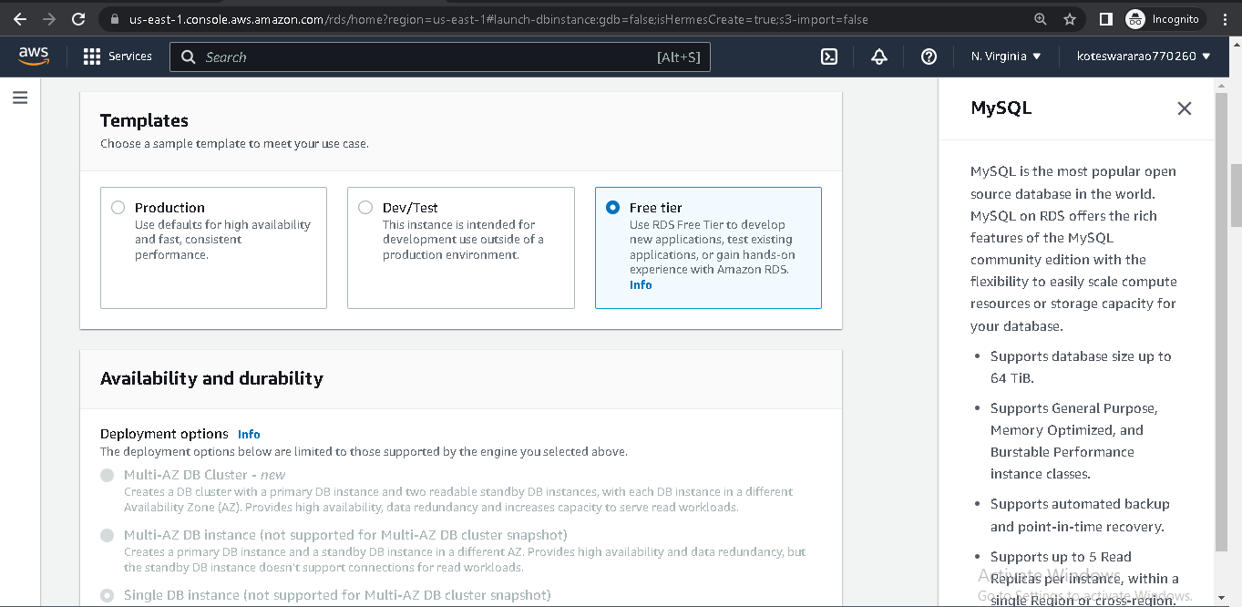

* Give credentials

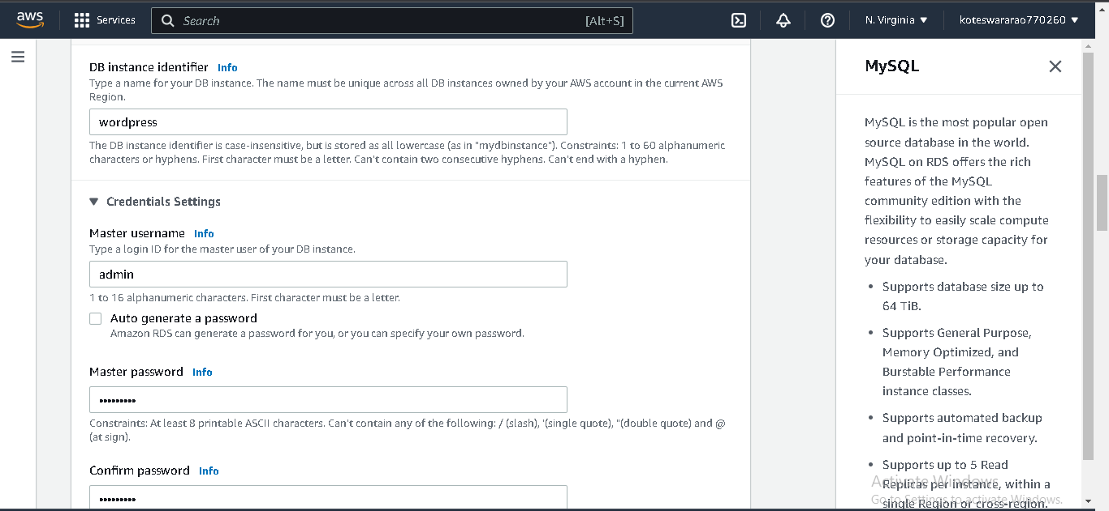

* Instance configure give

db.t2.micro

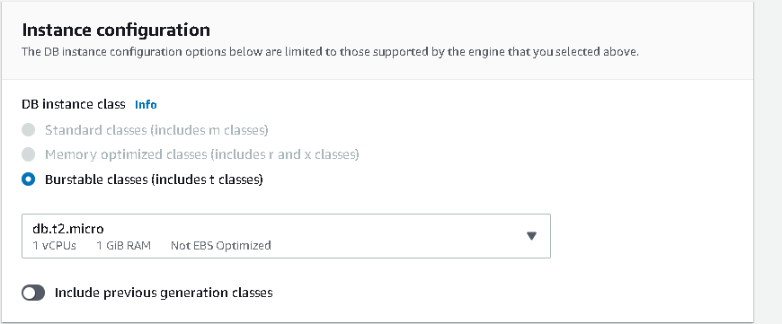

* Add storage

Storage type SSD gp2

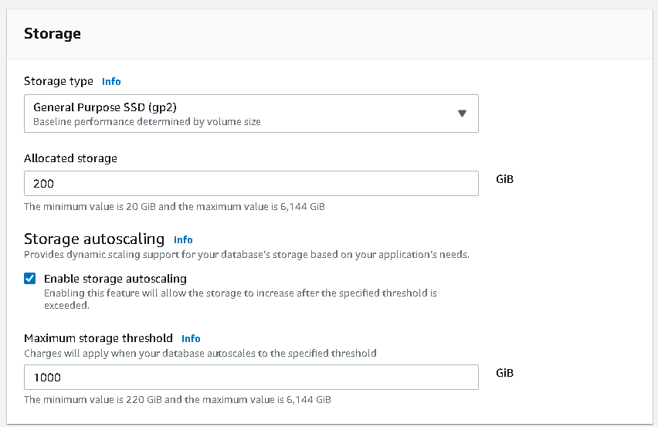

* Add Connectivity connections

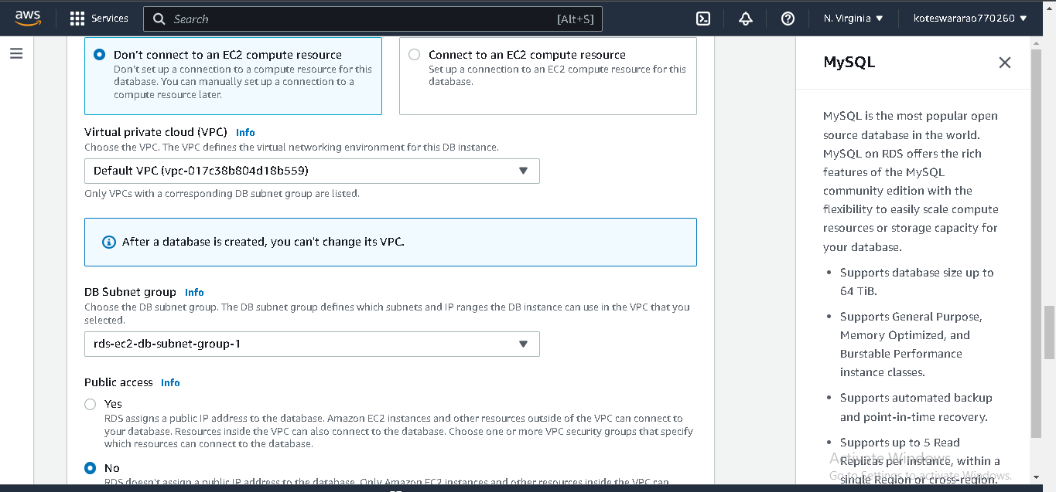

* Choose vpc security group
* Add additional settings

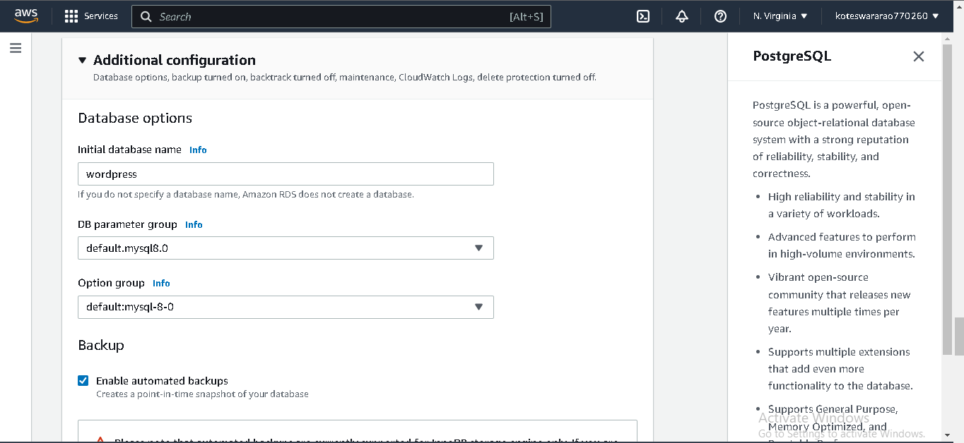

* Create database

LAB -2 : Create an EC2 instance to run wordpress site

* Go to EC2

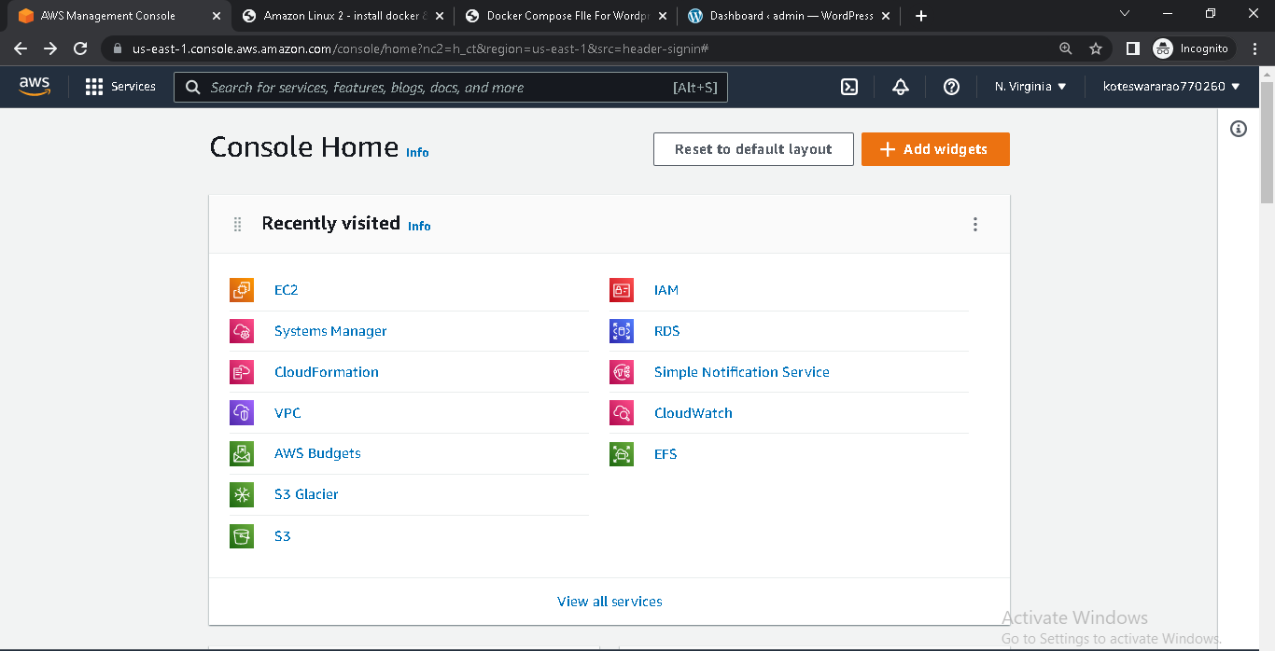

* Click on launch instance
* Choose AMI

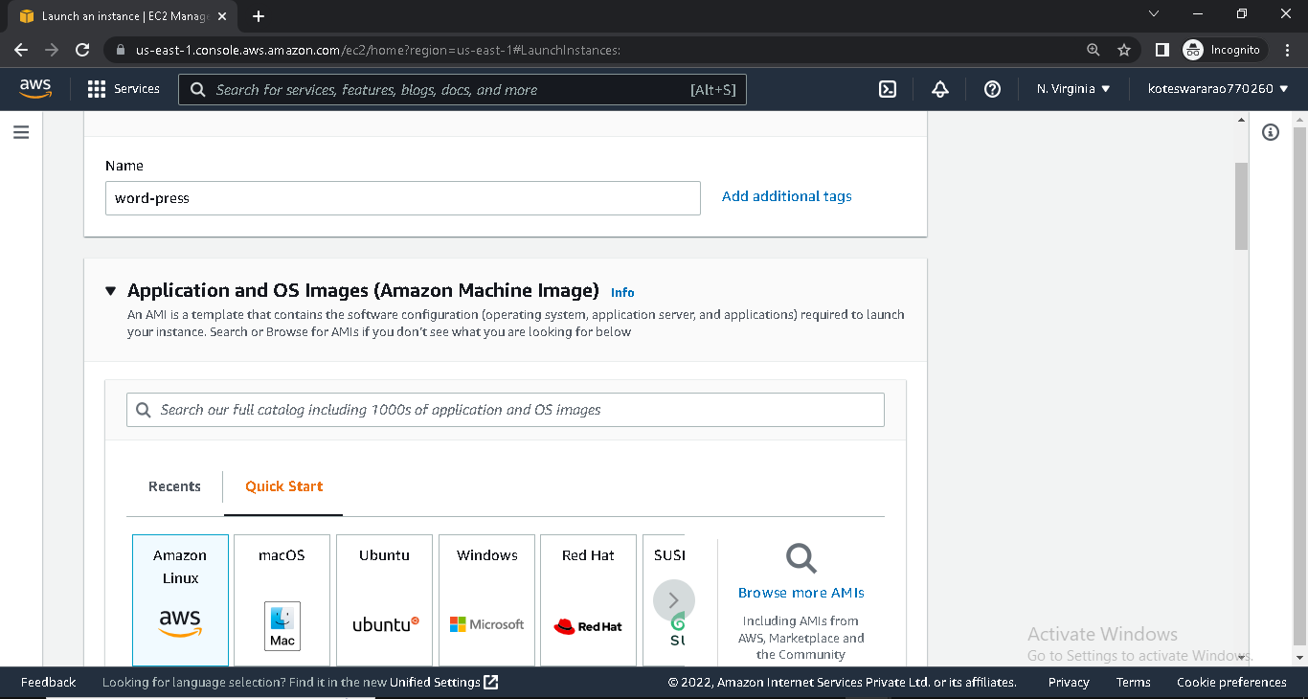

* Choose instance type
* Give key pair

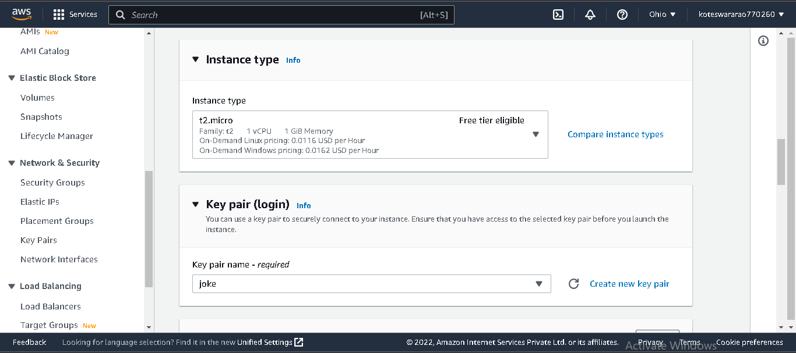

* Under Network setting ,

Choose vpc and subnet

Sercurity group

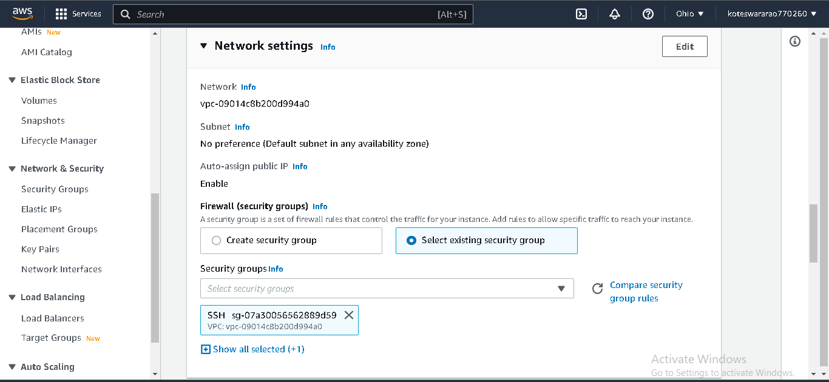

* Add storage (if require)

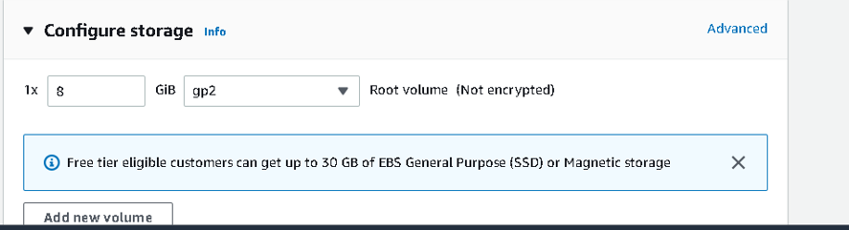

* Launch instance

LAB-3 : Configuring RDS Database

* First , you will modify your RDS database to allow network access from EC2 instance.
* In the previous module, you created security group rules to allow SSH and HTTP traffic your wordpress EC2 instance,the same principle applies here.
* This time, you want to allow certain traffic from you EC2 instance into your RDS database.
* Go to RDS and click on MYSQL database you created earlier.

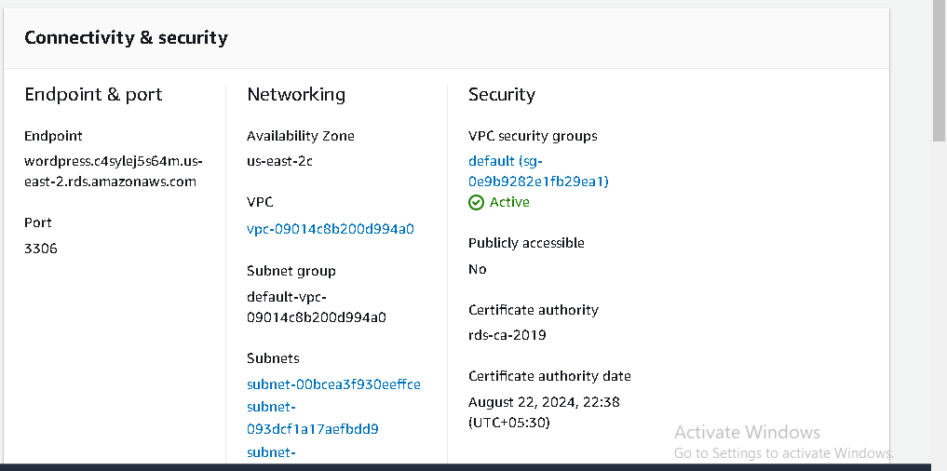

* Under security , we find security group and click on that
* It will go security page
* Click on the inbound tab and edit
* The default security group has a rule that allows all inbound traffic from other instance in the default security group.
* Change the type property to MYSQL/Aurora ,which will update the protocol and port range to the proper value.
* Remove the current security group value and type “wordpress” . the console will show the available security group.
* Click on the “wordpress” security group that you used for your EC2 instance and save it.

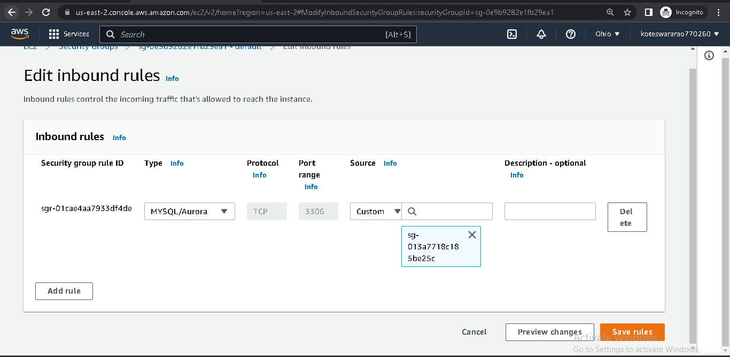

SSH client connect into terminal

* Go to terminal
* Go to downloads

Cd downloads/

* Type ssh –i <pem file> ec2-user@<public IP>
* Then, It will be going to connect
* In terminal, create MYSQL database

Sudo yum –y install mysql

C:\Users\admin\Pictures\install mysql db.PNG

* For connecting MYSQL into terminal

Export MYSQl_HOST=<end point>

mysql --user=<user name> --password=<password> wordpress

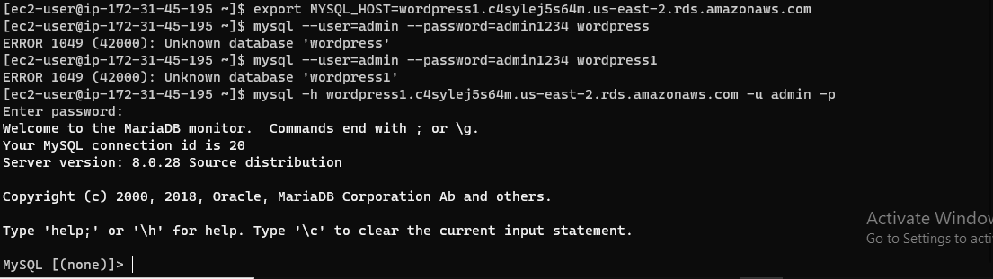

* Give permissions to access the “wordpress” database.
* Run the Following command in your terminal

CREATE USER ‘wordpress’ IDENTIFIED BY ‘wordpress-pass’;

C:\Users\admin\Pictures\CREATE USER.PNG

GRANT ALL PRIVILEGES ON wordpress.* TO wordpress;

C:\Users\admin\Pictures\GRANT PER.PNG

FLUSH PRIVILEGES;

EXIT

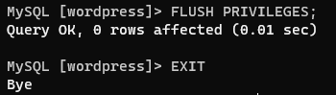

LAB -4 : Configuring wordpress on EC2

* Install HTTPD for run the wordpress

Sudo yum –y install httpd

C:\Users\admin\Pictures\httpd db.PNG

* To start the httpd and enable httpd

Sudo systemctl start httpd

Sudo systemctl enable httpd

C:\Users\admin\Pictures\start httpd db.PNG

* Check the server work or not

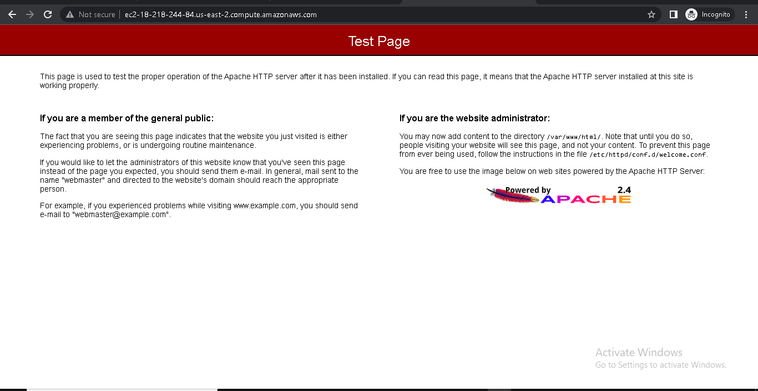

Download and configure wordpress

* Download and compressing the software by running the following commands

<https://wordpress.org/download./>

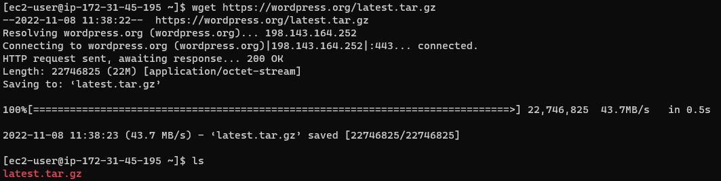

tar –xvf <tar file>

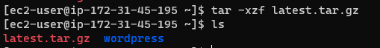

* Go into wordpress

Cd wordpress



* Create a copy of the default config file using

cp wp-config-sample.php wp-config.php



* Then , open the config file

Vi wp-config.php

* You need to edit two areas of configuration.
* Edit the database configuration by changing the following lines:

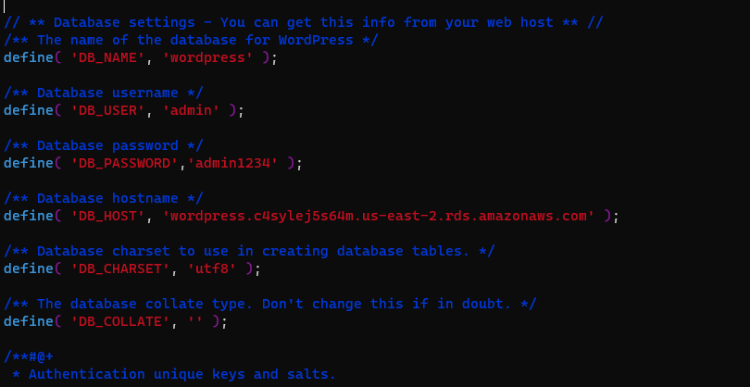

* Second configuration section you need to configure is the authentication unique keys and salt.

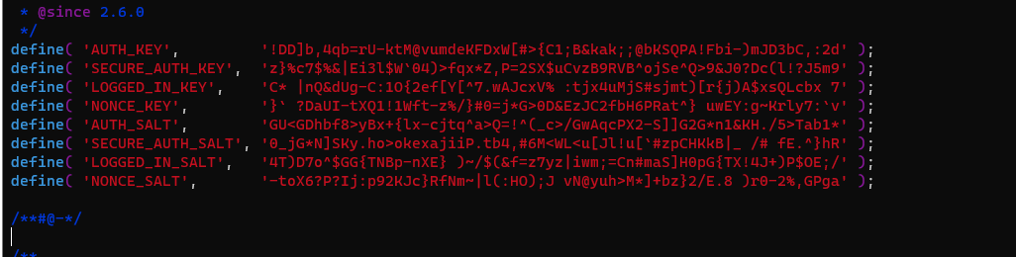

* You can replace the entire content in that section with the content from link:

Wordpress secrete key salts

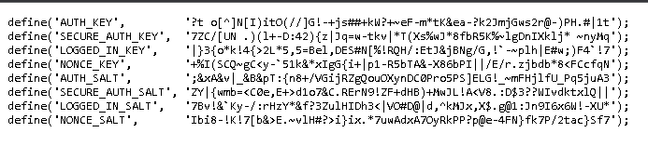

* Save the vi editor

Deploying wordpress site

* Install the application dependencies you need for wordpress. In terminal , run the following command

Sudo amazon-linux-extras install –y lamp-mariadb10.2-php7.2 php7.2

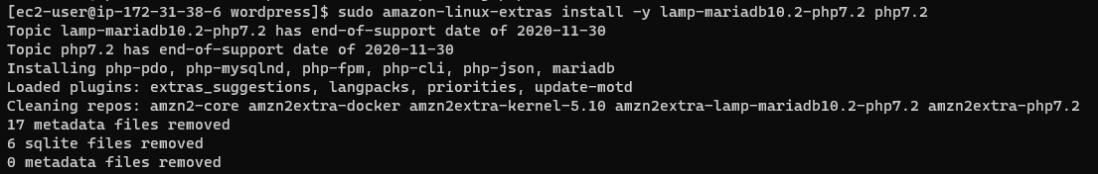

* Change directory

Cd /home/ec2-user

* Copy your wordpress application files into /var/www/html/ directory used by Apache.

Sudo cp –r wordpress/* /var/www/html/

C:\Users\admin\Pictures\wordpress copy inton var..PNG

* Finally, restart the Apache web server to pick up the changes.

Sudo systemctl restart httpd

C:\Users\admin\Pictures\restart httpd.PNG

* Reload the httpd page

